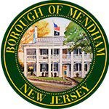
BOROUGH OF MENDHAM MEETING OF THE
MAYORS HISTORIC COMMITTEE
REGULAR MEETING MINUTES
July 29, 2026, 6:00PM
PHOENIX HOUSE, 2 WEST MAIN ST, MENDHAM NJ

CALL TO ORDER/ FLAG SALUTE
ROLL CALL
DISCUSSION ITEMS
- Communications
  - Social Media August Posting
- Current Events and Projects Updates
  - Recap on partnering with schools/arts
  - 250th Flags and Banners Updates
  - Labor Day Parade 2026
  - Fall Walking Tours Discussion
ADJOURNMENT

